In Memoriam
Name: Animesh Sarkar, 1965 ME
Date of Death: June 17, 2020
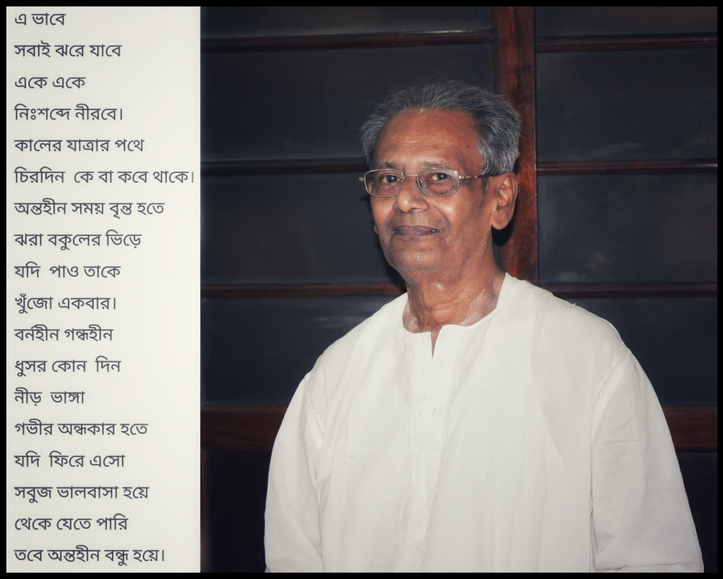
Details about Alum’s professional & personal life
Shri Animesh Sarkar, an alumnus of BEC 1965 Mech, suffered a massive cardiac arrest at around 02:30 PM and breathed his last (17.06.2020) without giving any time for medical intervention. His father, Ashutosh Sarkar, graduated in civil engineering from BEC in 1931. His elder brother, Amaresh Sarkar, a member of 1953 entrant batch of BEC graduated in Civil Engineering in 1958 and has been staying in the UK for the last six decades. His brother in law Late Chandidas Ghosh was also an alumnus of BEC (1958 Met).
Animesh Sarkar worked in HEC at Ranchi after passing out, took premature retirement and got himself self-employed in a different profession.
He was an out and out family man and used to keep regular contact with his relations.
Animesh Sarkar left behind his wife, three daughters who are well placed in life and a large number of relatives and friends.

Reported by: Syama Prasad Datta 1967 Civil

